**HRMS App:**  
  
"We've built a comprehensive HRMS app for ERPNext that empowers employees with on-the-go features. Users can effortlessly check in and out, capture location snapshots, submit leave requests, and view/download their Salary Slip directly from the app."

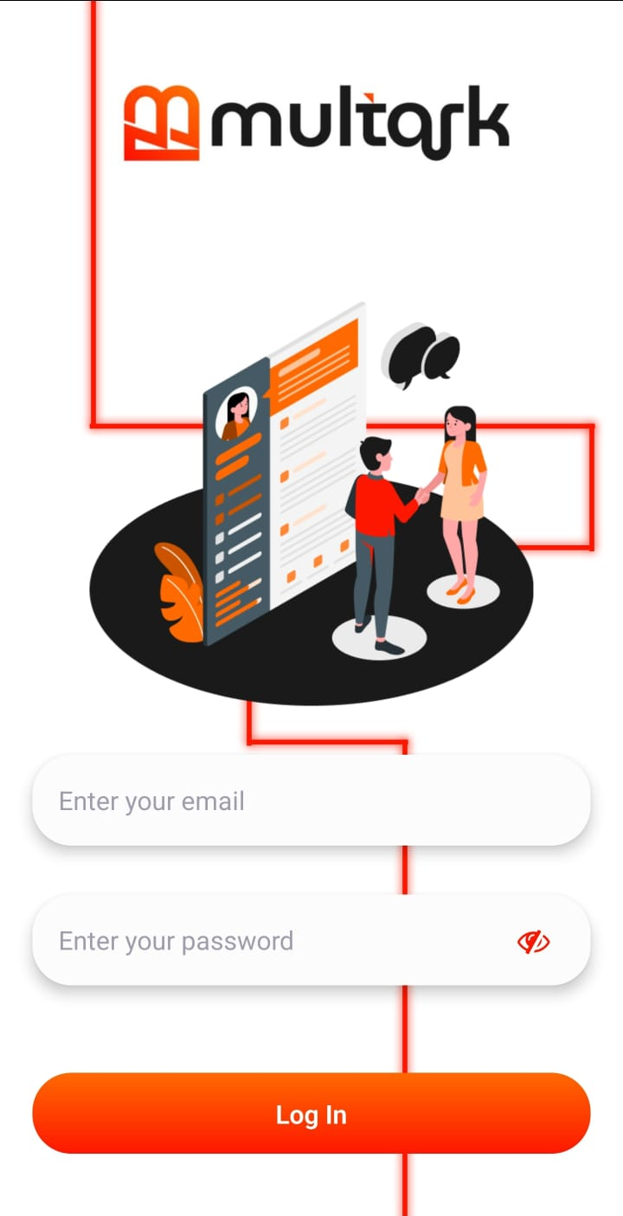 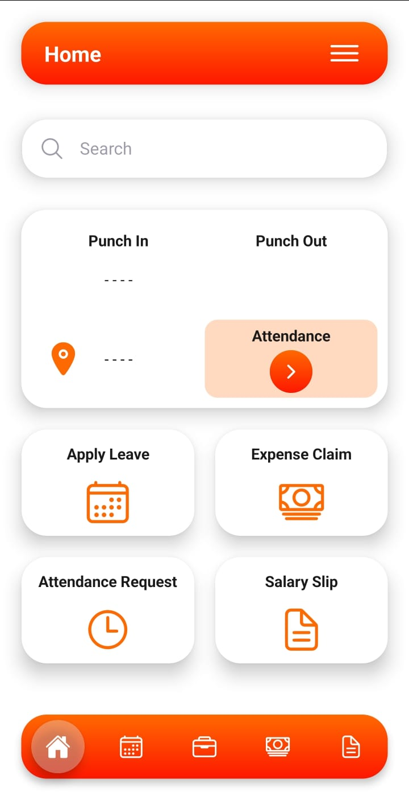

Key features include time tracking with location verification, leave management, and convenient salary slip access."

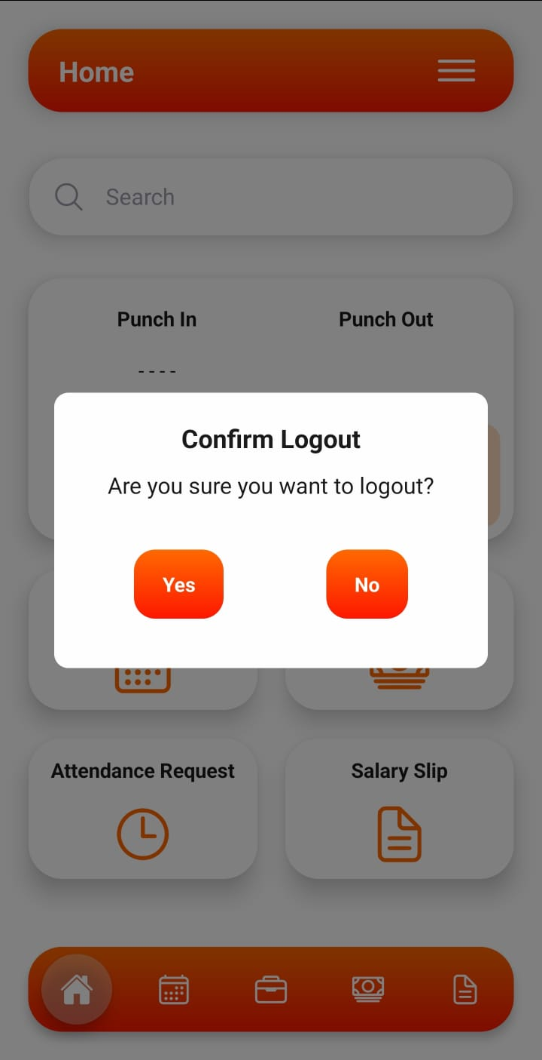

**Features and Functionality:  
  
Time Tracking:** App handle irregular work schedules, overtime, and remote work. Can login from anywhere since Geo-location is enabled, along with WFH options is been added with Outside Office work permission is being set. So even if the employee is working from outside office location he can marked his attendance.

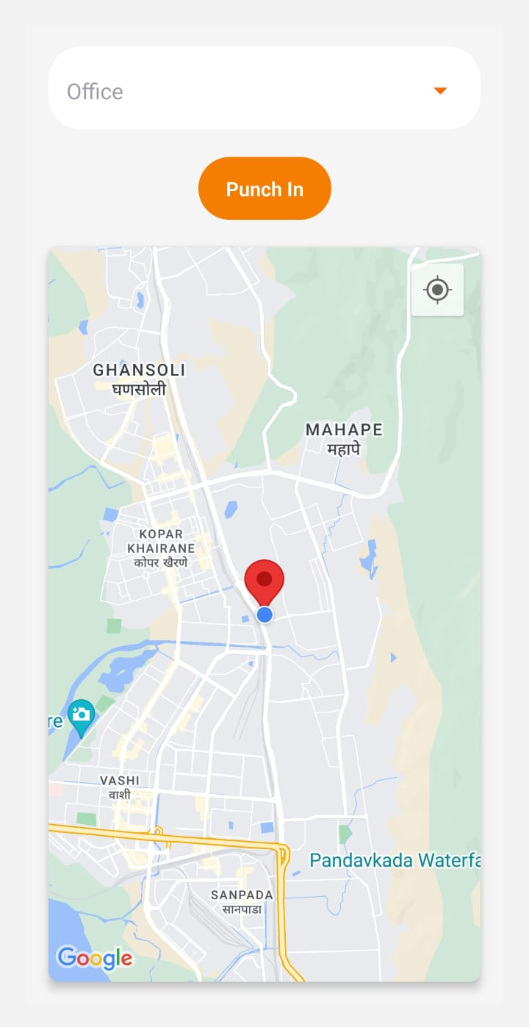  
  
**Leave Management:** It supports various leave types and what workflow is necessary for approval is mentioned.

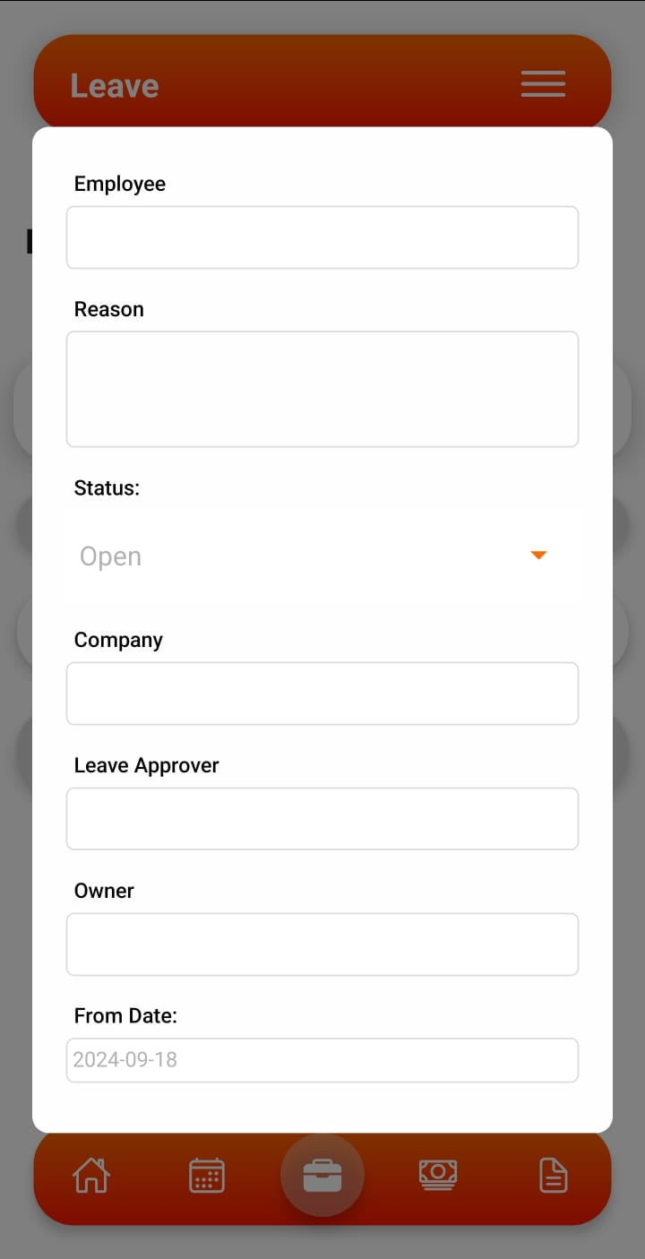

**Salary Slip:** He can view his salary slip for past months as well as past years.

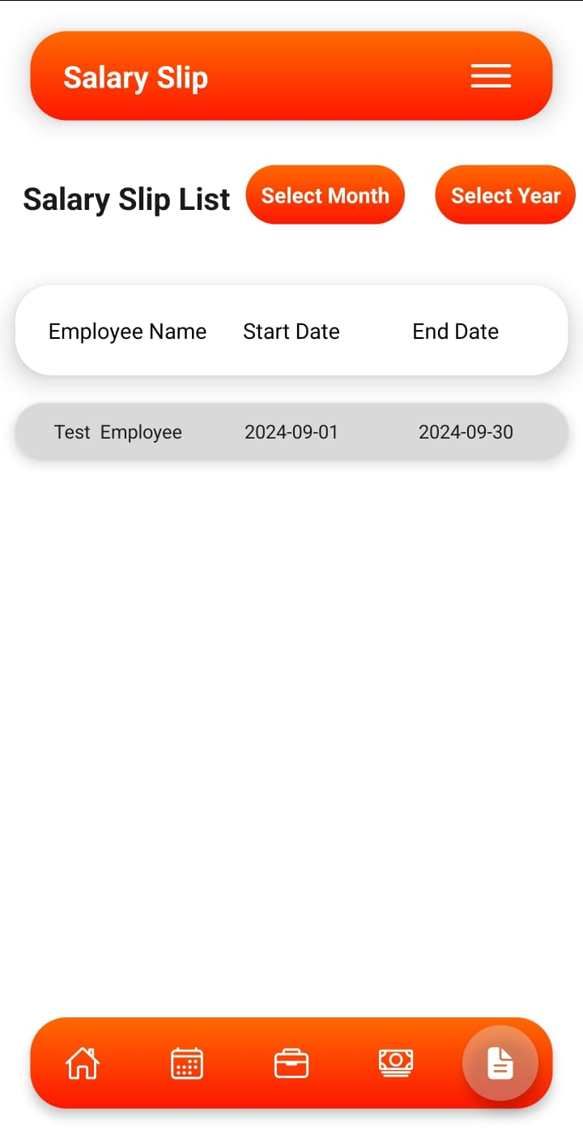

**Expense Claim:** Employee can claim any expense such as food, travel to company marking to his approvers.

